**Invoice Processing Using RPA**

Mr.Suresh Kumar.R1, Nandha kumar.A2, Rakshana.B3, Surya kala.M4

Professor1 UG Students2,3,4 , Department of Computer Science, KGiSL Institute of Technology, Coimbatore, TamilNadu, India

[1]

***ABSTRACT***

***The advent of Robotic Process Automation(RPA) has the potential to disrupt the traditional invoice model.With its capability to automate rules-based tasks that are repetitive and manual, RPA is expected to repurpose the role of the invoice by replacing perfunctory tasks and emphasizing higher order thinking skills that will eventually lead to enhanced invoice quality. This editorial envisages the future of the invoice by introducing the concept of RPA and describing its usage of UiPath tools . Moreover,considerations for RPA - based on invoice processing performed with help of UiPath. Collect a invoice template in different format and read those mails and receiving the mail with the help of IMAP.Processing those unread mails by using required activities.Depends om those activities we automated the mail. The convert those PDF file to Excel sheet format. And send a mail notification to the required client.***

**Keywords**- IMAP, RPA, UiPath, Invoice Processing, Excel Sheet

# **INTRODUCTION**

Robotic process automation(RPA) is rapidly changing the accounting and finance operations, arguably faster than any other piece of modern technology.Just for starters,it can be used to reduce data transcribing tasks by 80% in accounts payable,financial close,tax accounting and more,Robotic accounting is an increasingly popular solution for the limitations of legacy and disparate system found in the finance and accounting operations, which have had a direct effect on the operational efficiency of back office operations and internal customers of shared services functions. Robotic accounting, or robotic process automation in accounting the invoice processing, is defined as the use of automation application,like UiPath and Blue Prism,to reduce the amount of human labor required to process accounting and finance transaction just think of accounting robots as a tool that can reduce the effort needed to move routine data between accounting different accounting system and outside applications,instead of just being confine to one.Accounting RPA is an often perceived as the human replacement, but accounting robotics is more of a finance and accounting the operations and reduce data movement of the software applications like UiPath, Blue prism and then automated anywhere have simplified the work and the skills of the required accounting workforce and robotics assistants by they removing the need to understand the computer code to integrated the data movement in between the multiple data sources.

# LIterature Survey

A systematic review of the literature consists on identifying, evaluating and interpreting all available information on a research topic or phenomenon of interest by using a reliable,audit and rigorous methodology.This systematic review consists of three phases:(i) planning the review ,(ii) conducting the review, and (iii) reporting the review.

1. Planning the review

This phase consists of establishing the steps that will be performed during the review,for which research question and strategies of search are determined.This phase consists of two steps (i)establishing the research question and (ii) defining data sources and search strategy.

* Establishing the research questions

The research question that has been stated defines the scope of the systematic review and it is as follows:”what is the state of the art regarding electronic invoicing and information systems or platforms that use notifications?”

* Defining data sources and search strategy

The following digital libraries have been selected for automatic search:IEEXplore,ACM Digital Library, Springer Link,Science Direct,and Google Scholar.For the manual search the best conferences and magazines related to the topic of electronic commerce have been chosen.Table I shows the conferences and selected journals where papers have been found that could not be retrieved by the automatic search and whose content is representative for the research.

In order to perform the automatic search a string was defined based on keywords related to subject of the inverstigation.This string was chosen at investigators’criteria,after a process of multiple attempts with different combinations of possible keywords.

Drawbacks of existing methods

* There are some potential downsides to using invoices, but these are mostly caused by poor management and inadequate process.
* High operational costs per invoice  on both sender and receiver side.

# Proposed System

Invoice processing system is used to overcome the entire problem which they are facing currently, and making complete automation of billing system.

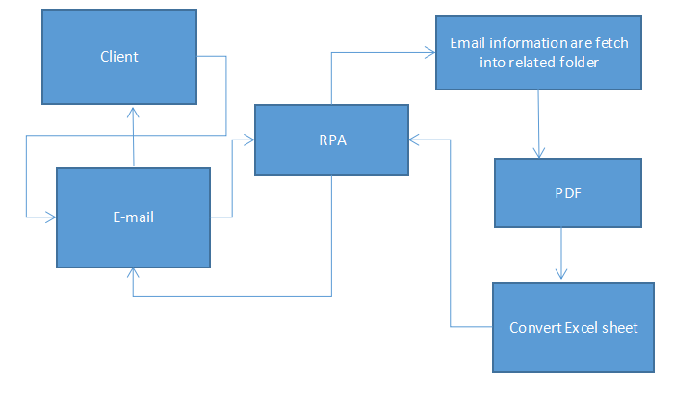

Fig1. Proposed System Work Flow

The client can be send the invoice through the email to the required organization , in that organization fetch the email information through RPA and then bot, can automated the required process that they generate the PDF format and convert to excel sheet and the bot sends the email notification to the client .

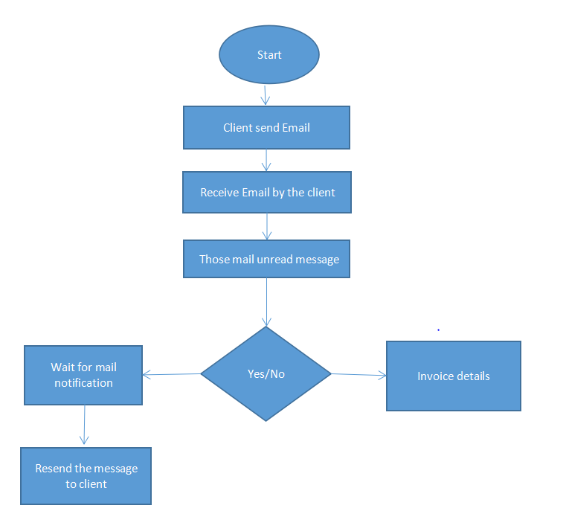

Fig.2 Flowchart of Proposed system

A flowchart is a type of diagram that represents an algorithm, work flow or process. The flowchart shows the steps as boxes of various kinds, and their order by connecting the boxes with arrows. This diagrammatic representation illustrates a solution model to a given problem.

This process will check the invoice details and if the details are send by the client.Receive the payment details of invoice process should be done.Details will be send to the required client. If it not done resend the message to the client and wait for mail notification.

**DATA FLOW DIAGRAM LEVEL 0**

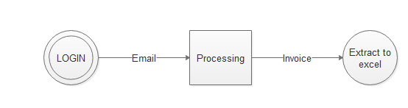

Fig.3. Data flow diagram level 0

This is the basic outline for the invoice process.All the invoice details are send by the client those invoices are pre-defined fromat containing no hand written text.Each document spans across approximately 3 pages.It can ,be mobile captured images,scanned PDFs.Data retrieved from the excel sheet send the mail notification to required client.

**DATA FLOW DIAGRAM LEVEL 1**

The unread message are direct to the required folder and those file are PDF format that can be attach into Excel sheet and send to mail notification to required client.

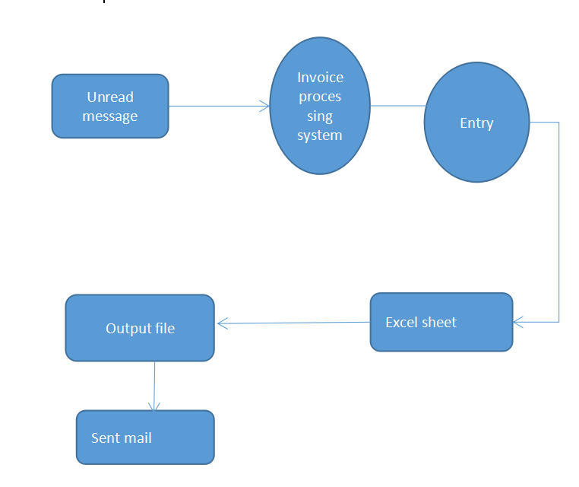

Fig.4. Data flow diagram level 1

**OUTPUT AND RESULTS**

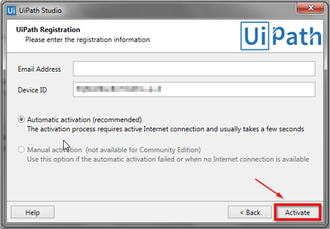

Fig. 5. Ui Path Registration form

**UiPath Studio – Level 0**

This is the starting page for Uipath studio. It is to register Mail ID. After registration, the process will be activated.

**Level 1**

This is the flowchart for the process.Email attachment to required invoice processing ,start the process and then check the internet status and get the password and receive the process by using the IMAP mail message to receive the those invoice details.

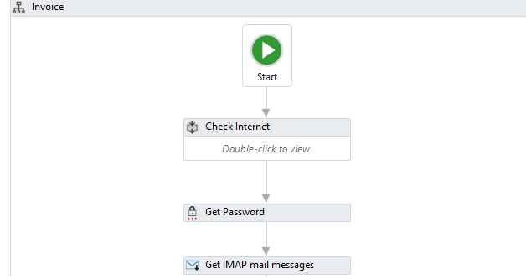

Fig. 6. Ui Path importing Email processing

**Level 2**

Receiving the those mail and attached into required folder.

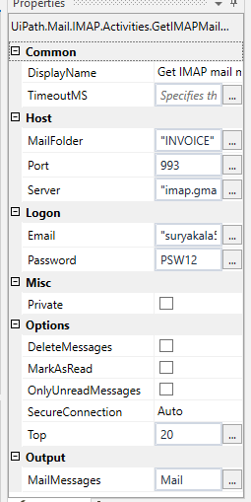

Figure 7

**Level 3**

Attached mail into required folder and write into pdf

format and execute those process

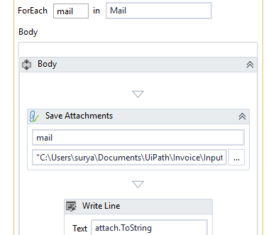

Figure 8

**Level 4**

Executes the email attachment of the required invoice processing .

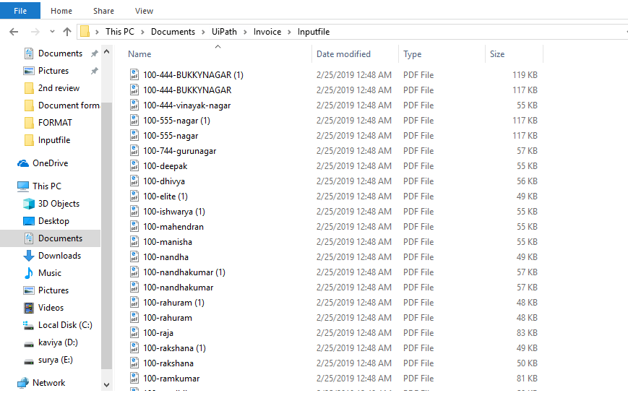

Figure 9

**Level 6**

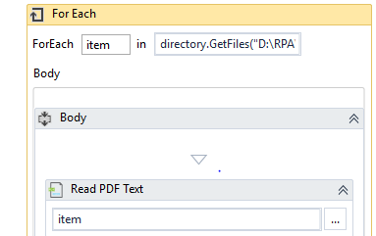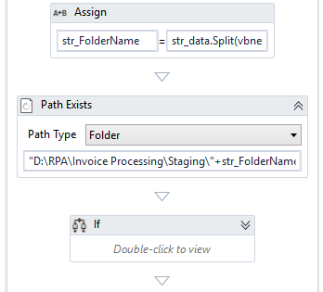

Figure 10

**EXCEL SHEET**

Excel is easy to use, accessible, and highly popular. Nonetheless, it is not always user-friendly and can at times prove to be very time-consuming and hard to integrate with other applications. In this excel, the frequently travelled customers details are shown as output.

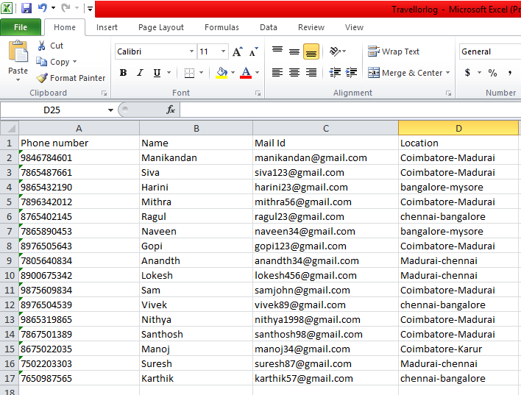

Figure 11

# **Conclusion And Future Enhancement**

In this process client can be send the invoice details to required organization,mails are attached to the required folder those file are pdf format and the attached into excel sheet ,send the mail notification to required client.Once that bot can be run it can be reduce the manual processing and reduce time consumption.

# **References**

1. A. Rofhök-björni, “Electronic Invoicing in Finland - attitudes towards electronic invoicing by financial managers in small- to mid-sized companies,” Swedish School of Economics and Business Administration, 2006.
2. A. Kaliontzoglou, P. Boutsi, and D. Polemi, “eInvoke: Secure e-Invoicing based on web services,” Athens, Greece, 2006.
3. A. Matus et al., “On the development of an electronic invoicing solution to integrate SMEs with a taxcollection egovernment-platform,” Sangolquí, Ecuador, 2017.
4. C. Legner and K. Wende, “Electronic bill Presentment and Payment,” St. Gallen, Switzerland, 2006
5. D. Spanic, D. Ristic, and B. Vrdoljak, “An electronic invoicing system,” Zagreb, Croatia, 2011.
6. E. Penttinen, P. Hallikainen, and T. Salomäki, “Impacts of the implementation of electronic invoicing on buyerseller relationships,” Helsinki, Finland, 2009.
7. J. W. Lian, “Critical factors for cloud based e-invoice service adoption in Taiwan: An empirical study,” Int. J. Inf. Manage., vol. 35, no. 1, pp. 98–109, 2015.
8. S. Suwisuthikasem and S. Tangsripairoj, “E-Tax Invoice System using Web Services technology: A case study of the Revenue Department of Thailand,” Bangkok, Thailand, 2008.
9. T. Kwok, J. Laredo, and S. Maradugu, “A web services integration to manage invoice identification, metadata extraction, storage and retrieval in a multi-tenancy SaaS application,” New York, USA, 2008.

1.